Technical Document

for

Jelblob: The Horrific Adventure

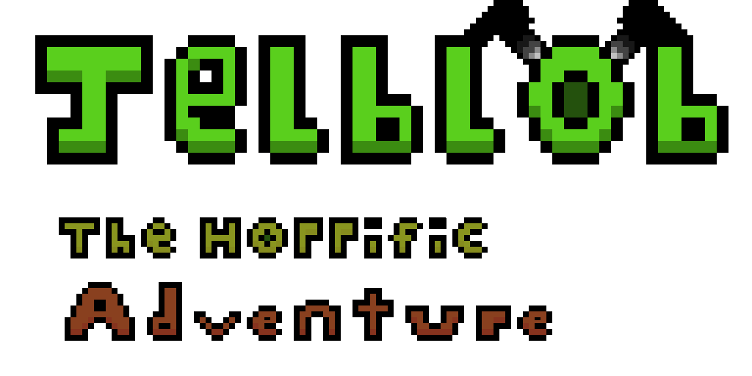

Table of Content

Role Assignments 3

Overview 3

Project Brief 3

Project Goal 3

Software 4

Hardware 4

Software Development 5

Methodology (explain how used in the development of the game) 5

Production – Assets and Audio 5

Pseudocode (screen shots of code in document or appendices) 5

(UML – Class Diagrams – Steven) 5

Testing – Justification of testing approaches adopted 5

Test plan (relate this to Quality Assurance) 5

Test Log 5

Evaluation of the prototype 5

Video demo (copy url into document) 5

# Role Assignments

|  |  |  |  |
| --- | --- | --- | --- |
| **Name** | **Banner ID** | **Course** | **Role in Project** |
| Alistair Walker | B00305911 | Computer Games Technology | Lead Artist  (With sub roles in Design and Programming) |
| **Description** | | | |
|  | | | |
| Kenny Melvillie | B00323186 | Games Development | Lead Games Designer, Audio Designer  (With sub roles in Programming and Artist) |
| **Description** | | | |
|  | | | |
| Steven O’neill | B00339826 | Games Development | Lead Programmer  (With sub roles in Artist and Design) |
| **Description** | | | |
|  | | | |

# Overview

## Project Brief

The purpose of this project, is to develop a working prototype of game as a project team that follows closely to the team’s design and technical design documents. The project team can choose any genre for their specific game, either from a 2D or 3D perspective using the appropriate game engine (Unity, Unreal Engine 4, Game Maker etc.) to aid their implementation requirements.

For our project, we have tasked ourselves with creating a 2D Side-Scrolling Platformer titled “Jelblob: The Horrific Adventure”, using the game engine ‘Unity’ for development of the title, and coding the game using C# in Visual Studios.

## Project Goal

The aim of this project is to create a playable prototype with at least one level that can be played from start to end. The player controlled character should be able to move left/right and being able to jump as well as firing projectiles, and should be able to end the level by passing a goal which the player must traverse hazards and enemies along the way.

## Software

* Unity 2017
* Visual Studios 2017
* Audacity
* Aseprite
* Microsoft Word
* Microsoft PowerPoint

|  |  |
| --- | --- |
| **Software Used** | **Description** |
| Unity 2017 | The Game Engine that is used for developing the game. |
| Visual Studios 2017 | The Software that is used to code the game. |
| Audacity | The program that is used for recording and editing audio into a suitable format for Unity. |
| Aseprite | The software that is used for the creation of sprite assets (characters, objects, background etc.) and other forms of artwork for Unity. |
| Microsoft Word | The software that is used for the documentation of the project, writing down the design and technical documents. |
| Microsoft PowerPoint | The software that is used to present the game to the audience in a presentation manner. |

## Hardware

# Software Development

Agile Development - "The ability to create and respond to change in order to succeed in an uncertain and turbulent environment." -*2001, the Agile Manifesto*

One of the main reasons behind choosing agile development was the high communication between team members it created, ensuring we were on the same page at all times. This collaboration helped keep track of all the puzzle pieces from scripting to sprites and audio, or just changes to the level layout.

By continuous testing throughout the development stage, minor bugs or errors could be detected and resolved earlier than other methodologies and stopped them from becoming a bigger pain further down the line, if even found!

Due to a problem with version control my particle system was malfunctioning and garbage collection failed, but I managed to catch it early enough to resolve the issue. Enemy circle colliders without triggers were also not reducing health due to a small tick box, but found early enough as this is an easy miss further down the line.

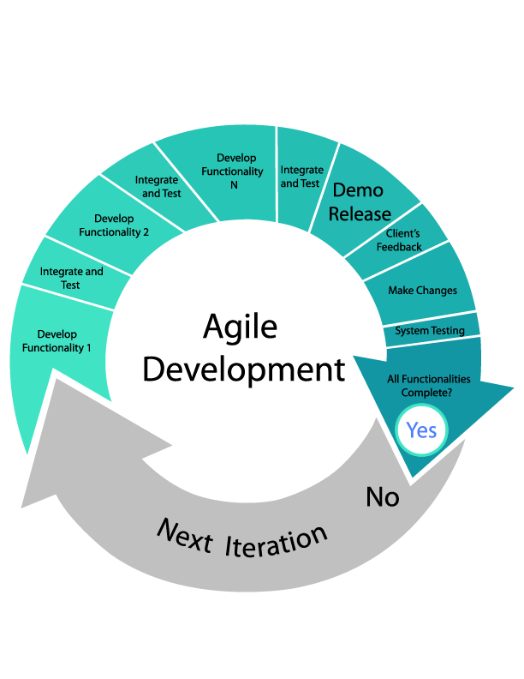

## Production – Assets and Audio

## Pseudocode (screen shots of code in document or appendices)

## (UML – Class Diagrams – Steven)

UI (detail this here)

# Testing – Justification of testing approaches adopted

## Test plan (relate this to Quality Assurance)

## Test Log

## Evaluation of the prototype

## Video demo (copy url into document)